# Multilevel Truncated Negative Binomial Model Results

## Fixed Effects Coefficients

| Estimate | Std. Error | z value | P-value | Variable |
| --- | --- | --- | --- | --- |
| 0.5360 | 0.1602 | 3.3465 | 0.0008 | (Intercept) |
| 0.0008 | 0.0004 | 1.8588 | 0.0631 | import_from_slu_log |
| 0.0071 | 0.0001 | 51.8605 | 0.0000 | age |
| 0.0963 | 0.0200 | 4.8071 | 0.0000 | distance_miles_log |
| -0.0325 | 0.0029 | -11.3037 | 0.0000 | state_unemployment |
| -0.0011 | 0.0001 | -7.9587 | 0.0000 | immigrant_density |
| 0.0093 | 0.0036 | 2.6187 | 0.0088 | sex_enc1 |
| 0.0209 | 0.0121 | 1.7282 | 0.0840 | marital_status_enc1 |
| 0.0314 | 0.0044 | 7.1907 | 0.0000 | marital_status_enc2 |
| 0.1182 | 0.0203 | 5.8127 | 0.0000 | employment_status_enc1 |
| -0.0535 | 0.0284 | -1.8851 | 0.0594 | employment_status_enc2 |
| 0.4004 | 0.0233 | 17.2082 | 0.0000 | purpose_simple2 |
| 0.1027 | 0.2734 | 0.3757 | 0.7071 | purpose_simple3 |
| 0.3774 | 0.0294 | 12.8221 | 0.0000 | purpose_simple4 |
| 0.2731 | 0.0227 | 12.0139 | 0.0000 | purpose_simple5 |
| 0.1626 | 0.0092 | 17.6596 | 0.0000 | accomd_type_enc1 |
| 0.3142 | 0.0051 | 61.5177 | 0.0000 | accomd_type_enc2 |
| 0.1102 | 0.0053 | 20.8877 | 0.0000 | season_enc1 |
| 0.0838 | 0.0053 | 15.9115 | 0.0000 | season_enc2 |
| 0.1632 | 0.0054 | 30.2834 | 0.0000 | season_enc3 |
| 0.4202 | 0.0202 | 20.8277 | 0.0000 | tourist_type_enc1 |
| 0.0259 | 0.0099 | 2.6309 | 0.0085 | tourist_type_enc2 |
| -0.0719 | 0.0211 | -3.4125 | 0.0006 | region_climate2 |
| -0.0513 | 0.0062 | -8.2037 | 0.0000 | region_climate3 |
| -0.0560 | 0.0071 | -7.9380 | 0.0000 | region_climate4 |

## Incident Rate Ratios (IRR) for Fixed Effects

Incident Rate Ratios for Fixed Effects

| Variable | IRR | Lower CI | Upper CI | P-value |
| --- | --- | --- | --- | --- |
| (Intercept) | 1.7092 | 1.2487 | 2.3396 | 0.0008 |
| import_from_slu_log | 1.0008 | 1.0000 | 1.0016 | 0.0631 |
| age | 1.0072 | 1.0069 | 1.0074 | 0.0000 |
| distance_miles_log | 1.1011 | 1.0587 | 1.1452 | 0.0000 |
| state_unemployment | 0.9681 | 0.9626 | 0.9735 | 0.0000 |
| immigrant_density | 0.9989 | 0.9986 | 0.9992 | 0.0000 |
| sex_enc1 | 1.0094 | 1.0024 | 1.0165 | 0.0088 |
| marital_status_enc1 | 1.0211 | 0.9972 | 1.0457 | 0.0840 |
| marital_status_enc2 | 1.0319 | 1.0231 | 1.0408 | 0.0000 |
| employment_status_enc1 | 1.1255 | 1.0815 | 1.1713 | 0.0000 |
| employment_status_enc2 | 0.9479 | 0.8966 | 1.0021 | 0.0594 |
| purpose_simple2 | 1.4925 | 1.4259 | 1.5621 | 0.0000 |
| purpose_simple3 | 1.1082 | 0.6484 | 1.8940 | 0.7071 |
| purpose_simple4 | 1.4585 | 1.3768 | 1.5452 | 0.0000 |
| purpose_simple5 | 1.3140 | 1.2567 | 1.3738 | 0.0000 |
| accomd_type_enc1 | 1.1766 | 1.1556 | 1.1981 | 0.0000 |
| accomd_type_enc2 | 1.3692 | 1.3555 | 1.3829 | 0.0000 |
| season_enc1 | 1.1165 | 1.1050 | 1.1281 | 0.0000 |
| season_enc2 | 1.0874 | 1.0762 | 1.0986 | 0.0000 |
| season_enc3 | 1.1772 | 1.1649 | 1.1897 | 0.0000 |
| tourist_type_enc1 | 1.5223 | 1.4632 | 1.5837 | 0.0000 |
| tourist_type_enc2 | 1.0263 | 1.0066 | 1.0463 | 0.0085 |
| region_climate2 | 0.9306 | 0.8929 | 0.9698 | 0.0006 |
| region_climate3 | 0.9500 | 0.9385 | 0.9617 | 0.0000 |
| region_climate4 | 0.9456 | 0.9326 | 0.9587 | 0.0000 |

## Random Effects Variance Components

No random effect variance estimated for region_census.

## Variance Inflation Factor (VIF)

VIF Values (Note: VIF > 5 may indicate multicollinearity)

| Variable | VIF |
| --- | --- |
| Predictor 1 | 1.55 |
| Predictor 2 | 1.37 |
| Predictor 3 | 1.47 |
| Predictor 4 | 1.23 |
| Predictor 5 | 1.70 |
| Predictor 6 | 1.02 |
| Predictor 7 | 1.22 |
| Predictor 8 | 1.01 |
| Predictor 9 | 1.33 |
| Predictor 10 | 1.10 |
| Predictor 11 | 1.05 |
| Predictor 12 | 1.07 |
| Predictor 13 | 1.63 |

## Model Comparison (Truncated vs Non-truncated)

ANOVA Model Comparison Results

| Df | AIC | BIC | logLik | deviance | Chisq | Chi Df | Pr(>Chisq) |
| --- | --- | --- | --- | --- | --- | --- | --- |
| 27 | 742,295.0 | 742,560.6 | -371,120.5 | 742,241.0 |  |  |  |
| 27 | 747,937.9 | 748,203.5 | -373,942.0 | 747,883.9 | 0 | 0 | 1 |

## Model Fit Statistics

| Statistic | Value |
| --- | --- |
| AIC | 742,295.0 |
| BIC | 742,560.6 |
| Log-likelihood | -371,120.5 |

## Predicted vs Observed Length of Stay

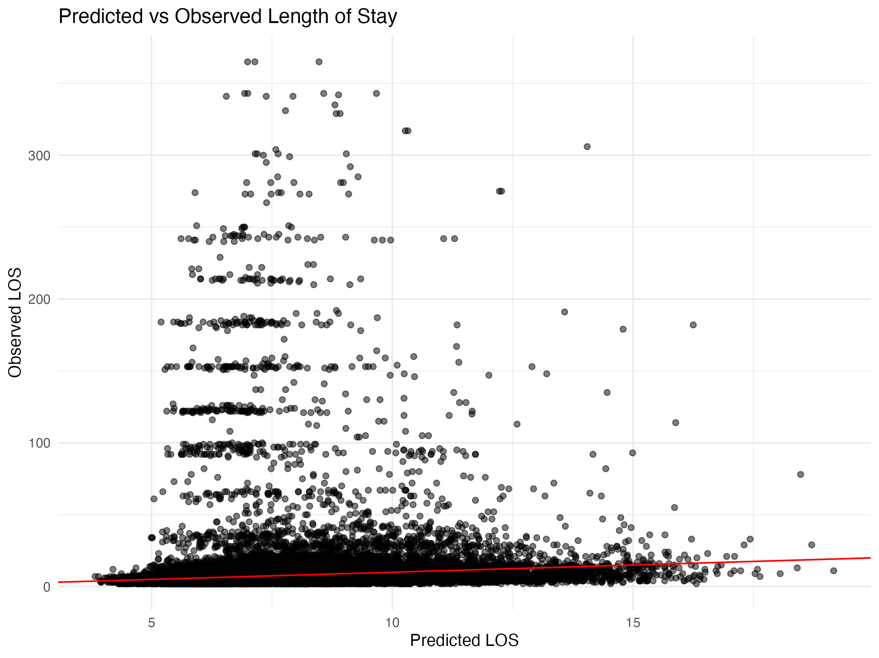

## Diagnostic Plots

### DHARMa Residuals

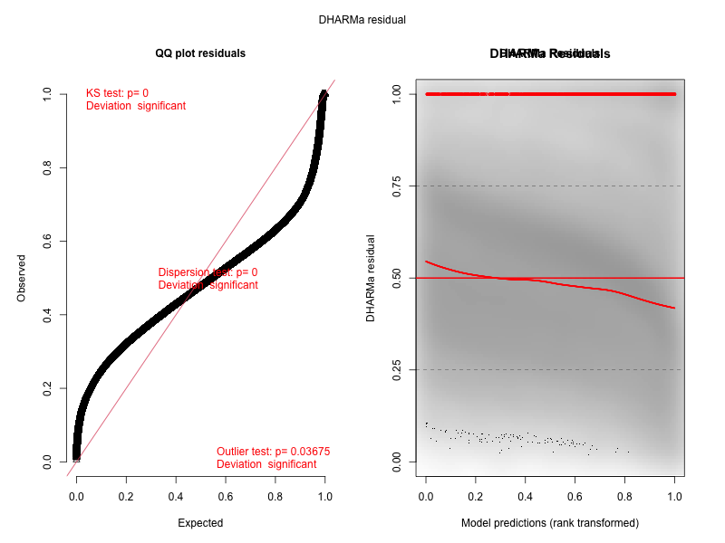

### Residuals by State

